**Machine learning Assignment.**

Jashwanth Reddy Anreddy 700741538

a. Using NumPy create random vector of size 15 having only Integers in the range 1-20.

1. Reshape the array to 3 by 5

2. Print array shape.

3. Replace the max in each row by 0

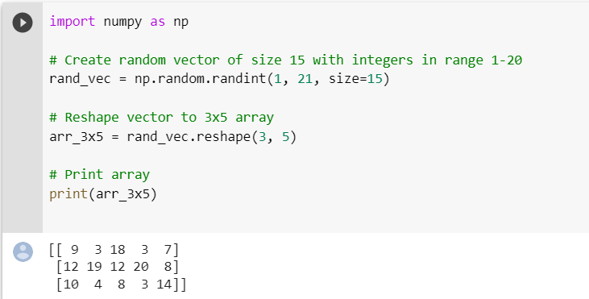

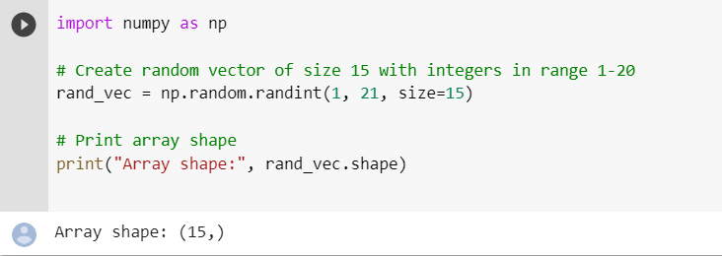

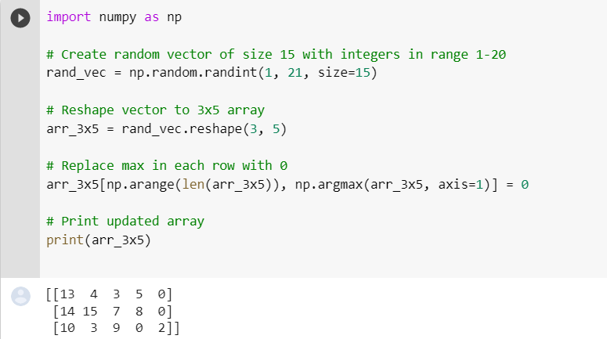

create a two dimentional array of size 4*3(composed of 4 byte integer elements )also print the shape type and datatype of the array

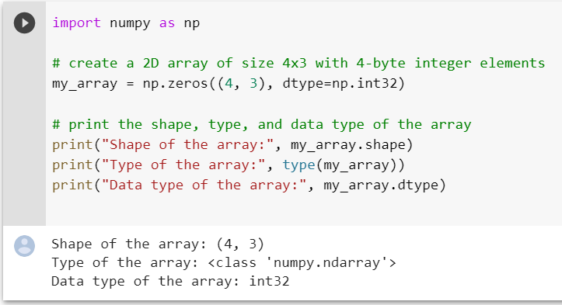

b. Write a program to compute the eigenvalues and right eigenvectors of a given square array given below: [[ 3 -2] [ 1 0]]

c. Compute the sum of the diagonal element of a given array. [[0 1 2] [3 4 5]]

d. Write a NumPy program to create a new shape to an array without changing its data. Reshape 3x2: [[1 2] [3 4] [5 6]] Reshape 2x3: [[1 2 3] [4 5 6]]

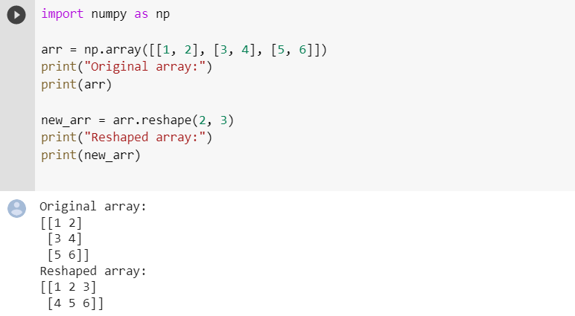

2. Matplotlib 1. Write a Python programming to create a below chart of the popularity of programming Languages. 2. Sample data: Programming languages: Java, Python, PHP, JavaScript, C#, C++ Popularity: 22.2, 17.6, 8.8, 8, 7.7, 6.7